LOCAL MEDICAL PROCEDURES – POGGIO RENATICO

1. Health Flowchart. This document is self-explanatory and shows the how/when you can/should proceed with treatment or contact HEALIX etc.

2. You are free to choose your own GP although the CEP is more likely to be able to maintain your records and arrange direct billing system with practices commonly used by the UK population. Primary care services have traditionally been provided by:

Dr Enrico Minganti +39 3683829469 Corso della Giovecca 203 Ferrara – Settore 2
Dr Benedetta Codecá +39 3400888348 Corso della Giovecca 203 Ferrara – Settore 2

- When you visit the doctor, where a cashless payment system is in place, you must compete an appointment form at the end of the appointment and hand it to the doctor for them to claim reimbursement.

- Always ask for the Doctor's consultation note completed by the GP at the end of the consultation this can be forwarded to SHAPE CEP as long as you have registered with them (spouses and dependents only as military personnel are automatically registered). .

- If you require care that cannot wait until the next working day, then attend the local Accident and Emergency department (A+E).

- If you attend A+E or are admitted to hospital unexpectedly contact Healix as soon as is possible.

- If you need the support of a clinical team out of hours the Healix Healthline is 24/7. They may be reached on +44(0)208 481 7800 or healthline@healix.com and can also reach the CEP clinical team when required.

3. The Paediatrician is classed as your children’s GP and therefore in accordance with the Medical flowchart an initial consultation does not require pre-authorisation.

- Contact Dr Nicoló Zanforlin at +39 3498768274 to arrange arrival consultation/familiarisation including mandatory vaccinations brief.

4. Direct Billing form for attending a Primary Care Consultation appointment– This form should be taken to all Primary Healthcare appointments where there is a cashless payment system in place. It should be completed by the patient at the end of the appointment and handed to the PHC provider in order for them to claim reimbursement. The PHC provider will attach their invoice to this form and forward it to the CEP for payment. It is recommended that personnel keep a stock of these as they must be completed for every appointment and they will be retained by the provider.

5. Direct Billing form for attending a Secondary Care Consultation appointment – Upon referral to a Secondary Healthcare provider (this includes MRIs, scans etc) personnel are to ensure they have received prior approval from Healix. Once this has been provided personnel should bring this form for all such appointments where a cashless payment system is in place. The HNLO will assist if required with booking the appointments. At the end of the appointment the individual should complete the form and hand it to the SHC provider who will attach their invoice and forward to CEP- for payment.

NB: Both of the above forms only apply to PHC’s and SHC’s providing a cashless payment system – for further guidance contact the EJSU Hd of Loc or the HNLO.

6. PHARMACY

We have a direct billing system with the Fides Pharmacy at Corso della Giovecca 125, you will require to produce your Codice Fiscale, Passport and your prescription in order to obtain free prescriptions along with the following:

Direct billing form for a pharmacy provider – this form must be completed by the patient and handed to the Pharmacy staff upon collection of a prescription (no exceptions).

Self-medication won't be reimbursed.

TREATMENT IN UK

7. HEALIX cannot authorise travel to the UK, this remains an EJSU responsibility, therefore immediately upon receipt of their intention to provide treatment in the UK, you are to report the facts to EJSU through the Head of Location (Usually by submitting an application to travel). NB. You do not have to provide the medical details/reasons to non-medical staff. EJSU SOM will advise if this UK treatment is authorised and if any subsequent travel/subsistence should be authorised by EJSU HQ.

PROCEDURES WHERE NO DIRECT BILLING IS IN PLACE

8. Where a PHC or SHC provider is used who does not provide a cashless payment system, personnel should settle payment personally, complete an EJSU JPA Claim Form (attached as a separate attachment) and reclaim the charges via JPA (exact instructions are on the EJSU JPA Claim Form). NB: All receipts must be kept for audit purposes and any SHC provided must be backed by Healix authorisation.

9. BFGHS FIN01F 01/16 EJSU JPA Claim Form. To be used to reclaim all costs where no cashless provider is used. Note personnel have 30 days to reclaim costs and all supporting documentation/receipts etc should be kept for audit purposes.

MEDICAL INTERPRETING SERVICE

10. Whilst most providers used in Ferrara speak English there are occasions where you may find yourself in a situation where the Healthcare staff you are dealing with do not speak English. Patients can make use of the ‘The Big Word’ Service which will provide confidential medical interpretation. Patients must be aware that this is for medical use only and should they use this service they must inform the CEP of the date, time and duration of the call.

11. Healix and the EJSU CEP are also able to give advice should you feel the need to discuss any treatment that you have been offered by the Italian Medical Authorities. It should be remembered that Healix provide the authority for medical treatment as this is checked with the appropriate care or treatment that you would receive/be entitled to in the UK.

The Big Word - only Medical Interpreting Service
1) dial +44 (0)1132124116
2) enter the access code 77451265
3) enter the language code 995
(Remember to direct your conversation to the client and not to the Interpreter)

Contacts:

EJSU-CEP +32(0)65442280 email: DPHCBFG-EJSU-CEP@mod.gov.uk

HEALIX Healthline +44 2084817800 e-mail: healthline@healix.com

Signed electronically

A Capolongo
HNLO EJSU Poggio Renatico

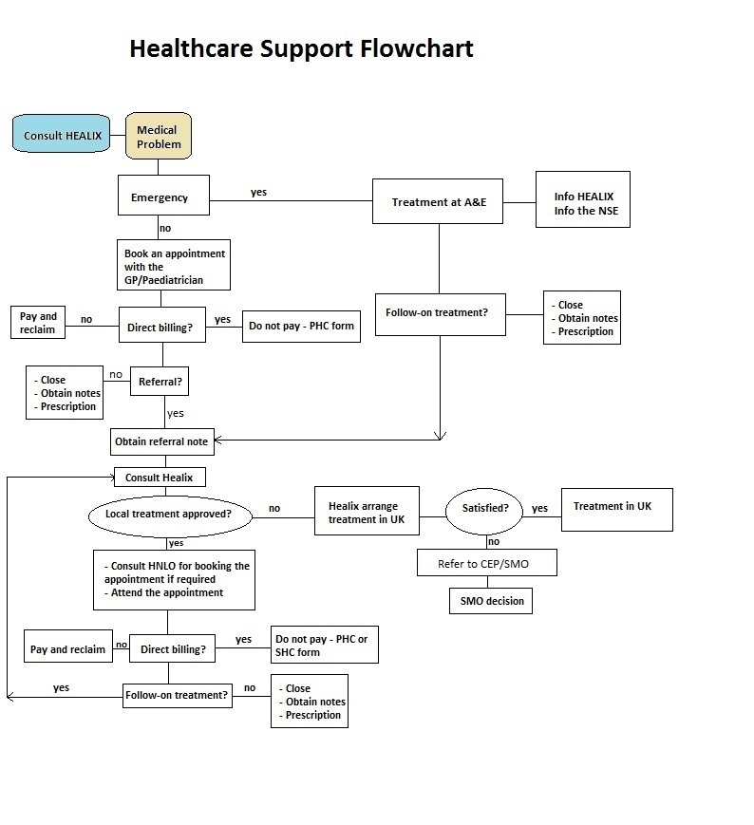
NOTES:
1. Always take the completed form for all the appointments where Direct Billing arrangements are in place
2. Always ask for copies of the Medical Referral Note - remind the GP to complete the Doctor's Consultation note form
3. On posting, ask the GP/Health provider for copies of all medical notes
4. Healix do not need to be consulted or informed for initial GP appointments
5. Claims for Medical Expenses/Prescriptions to be authorised by CEP before claiming on JPA. Medical notes are not required
6. Use the Big Word for medical interpreting service only - 1) dial +44 (0)1132124116 - 2) enter the access code 77451265 - 3) enter the language code 995

