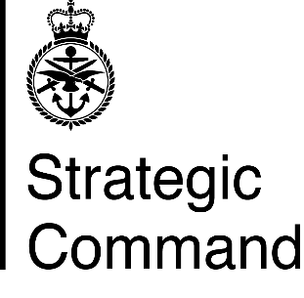 | Lieutenant Colonel J F A Craven Royal Artillery
 | Commanding Officer

European Joint Support Unit
Supreme Headquarters Allied Powers Europe,
British Forces Post Office 26

 | Email: Janathan.Craven131@Mod.gov.uk

17 June 2021

ALLOWABLE PUBLICLY FUNDED TRANSPORT COSTS FOR MESS EVENTS
Reference:
JSP 800 Vol 5 Road Transport Policy (V8.7 May 21).

1. The EJSU is entitled to up to 24 return journeys per year (12 to each Mess in a normal Unit). This will, therefore, be split evenly to each of our 8 Messes, giving them 3 return journeys per year. Key points to note are

a. Only the Messes in SHAPE, Naples, Brunssum and Ramstein will be entitled to claim transport costs as they are the only ones established under Queen’s Regulations.

b. That transport is only for Mess members. Their spouses/civil partners are only to travel on a spare seat basis. Associate members are also authorised, but the privilege is not extended to their spouses/civil partner (unless those spouses/civil partners happen to be members of the UK MOD). If the messes wish to provide transport for non-entitled associate members guests or other civilian guests, they may hire a minibus, but the hire will not be paid for from public funds.

c. The transport plan should, wherever possible, be from collection points rather than from individual members houses, and collection points must be less than 10 miles by road from the function. Taxis, service vehicles or MMA may not be claimed if no transport is available for individual members. The publicly funded transport must not deviate from its set route just to collect associate members.

d. When joint or combined functions are held e.g. JOM and WOs’ & Senior Rates have a joint Summer Ball, this combined function will count as one of the three allocated entitlement for each respective Mess.

e. For evening the events, the return journeys are to be completed by no later than 0030hrs. After that time, Messes are to organise and pay for their own return transport if necessary.

2. Should any further information be needed, please speak to:

The EJSU MT Section MTWO – WO2 Ross Stephen.Ross233@Mod.gov.uk

(Original Signed)

J Craven
Lt Col

Distribution:

SNRs
HoLs of NSE
PMCs of Messes in SHAPE, Naples, Brunssum and Ramstein

Copy to:

EJSU Comd Gp
QM
MTWO

