SHAPE & Brussels
Practice
October 2021

October 2021

CEP News

COVID Boosters for over 50’s – We anticipate a mixture of Host nation and UK clinic-administered vaccine for those over 50 and those with certain underlying health conditions. For most people on the UK program this will mean they become eligible in November.
We are currently working on the logistics of UK provision and may choose to minimise this where there is already an accessible host nation offer. At the moment European countries vary in their approach but if you are in an eligible groups and 6 months have passed since your second vaccine and Pfizer is available in your country of residence, you may wish to accept that offer. Please also let your practice know of the immunisation if you do accept one elsewhere.
COVID Vaccinations for 12-18 - The UK’s vaccination group have recently offered advice (here) that those aged 12-17 may be offered one dose of the Pfizer BioNTech (Comirnaty) vaccine. The Department for Health is currently beginning immunisation in the UK while the MoD and FCDO plan for the logistics of an offer to the small number of overseas U18s who are not incorporated in a host nation plan.
In Europe and Turkey many of our countries of residence are already offering two doses of Pfizer to young people and many have taken this up already. We have reached out to all NSEs and are not aware of many issues with access but if you have any concerns then get in touch direct with your practice as well as letting the NSE know.
We understand that differing approaches to immunisation and certification between the UK and other nations creates challenges for those who live or travel between two regions (in particular children who are at school in the UK). There is no one-size-fits-all answer to this but individual preferences; the HN offer; and the residency status of the child will

play a part in family decisions on whether to aim for a local vaccination. In making this decision, it is also worth highlighting that the MoD has no authority to move ahead of the NHS program (which allows only one jab at the moment) and we also have no immediate access to our own stock of Pfizer vaccine in most locations. Therefore, please consider the HN offer of Pfizer for U18s and accept it should you wish to.
- Please ensure you and your child (over 12) have considered the Host Nation offer of Pfizer immunisation, using UK and HN advice, and taken it up if you wish to. This is the only current means of access to immunisation out of the UK for children across Europe and Turkey.
- Records: The details of any immunisation undertaken in the host nation (including type, batch number and date of expiry) should be sent to your practice so we can update your Defence medical and NHS record. NB.
- Although we can include those aged 12-17 in the NHS clinical system, under 16s across the UK have no access to NHS online certification. If they need to demonstrate proof of immunisation for life overseas this will currently need to be on the host nation system.
MoD view on HN offer: JSP 950, Leaflet 7-1-1 (linked on ModNet here): So long as the HN-provided vaccine is compliant with the EMA/FDA/MHRA conditions of authorisation an individual (or the person with parental responsibility) can accept the offer of a HN vaccine under the principles of informed consent (noting that children aged 16-17 are often competent to give their own consent).

Third primary doses -A very small number of people in the UK MoD population require a third primary dose of vaccine due to having a condition or taking medicines that affect the immune response.
This third dose is usually with Moderna or Pfizer vaccines (the mRNA types). We are reaching out to these people to ensure a HN or UK offer is in place but if you are in these groups and have not yet been contacted please give your practice a call.
Third primary COVID-19 vaccine dose for people who are immunosuppressed: JCVI advice
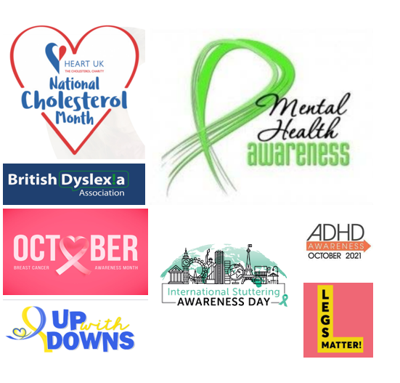
OCTOBER HEALTH PROMOTIONS
National Down Syndrome Awareness
Breast Cancer Awareness
National Cholesterol Month
ADHD Awareness Month

Awareness Days:
10th – National Mental Health Day
7-12th – Dyslexia Awareness
11-15th – Legs Matter
16th – Restart Your Heart Day
22nd – International Stammering Awareness
23rd – Wear it Pink

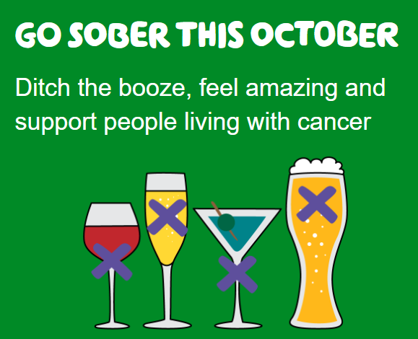
Macmillan Cancer Support are asking you to get involved in Sober October by going alcohol-free in October to raise money for people with cancer.
You can choose to have a Sober October by taking on the challenge for 21 or 14 days,or go old school and challenge yourself to take on the full 31 days.
We need you to do whatever it takes to help people living with cancer. The pandemic has had a huge impact, with thousands of people having their cancer treatments delayed. No matter what you choose to give up, or how long you choose to go sober for, you will be raising vital funds to help Macmillan continue being there for the millions of people living with cancer in the UK right now.
And you’re not just helping others, you’re helping yourself too. Having a break from alcohol has great health benefits, such as having more energy, a clearer head and sleeping better, plus no hangovers!
More Information:
COVID-19 vaccination: resources for children and young people
JCVI statement, August 2021: COVID-19 vaccination of children and young people aged 12 to 17 years
COVID-19 vaccination programme
Contact your practice:
SHAPE & Brussels Practice - UKStratCom-DMS-DPHC-MON-Grp@mod.gov.uk

