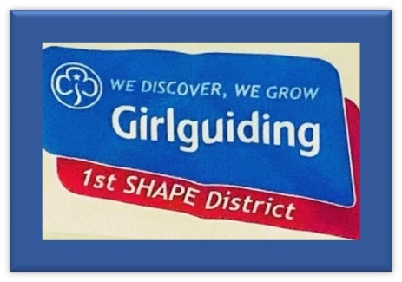

Girlguiding S.H.A.P.E District (Benelux and France) British Girlguiding Overseas is part of UK Girlguiding.

Situated in the community of SHAPE HQ at Mons, Wallonia Belgium.

With 30 NATO member nations and additional partner and military cooperation nations represented at SHAPE, we truly are a diverse community.

Girlguiding S.H.A.P.E District comprises of three units.
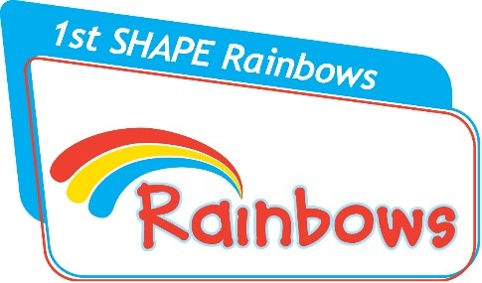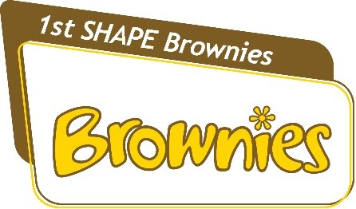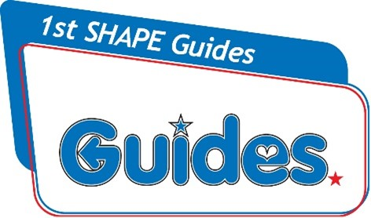
1st S.H.A.P.E Rainbows 1st S.H.A.P.E Brownies 1st S.H.A.P.E Guides

S.H.A.P.E Girlguiding District Unit Details

Rainbows (5 - 7)
1st S.H.A.P.E Rainbows learn by doing – they get their hands dirty, do sports, arts and crafts and play games. Being a Rainbow is all about having the space to try new things. Through taking part in a range of different activities with girls their own age, Rainbows develop self-confidence and make lots of new friends,
Meet every Tuesday (excluding school holidays) from 15:30-17:00pm
Email: GirlguidingShape@outlook.com

Brownies (7 - 10)
1st S.H.A.P.E Brownies have incredible experiences together, make brilliant friends and discover the world around them. Every time they meet up, groups of Brownies learn new skills and take on challenges as they work out what they want to be and do in the future.
Meet every Wednesday (excluding school holidays) from 15:00-17:00pm
Email: SHAPEbrowniesno1@outlook.com

Guides (10 – 14)
1st S.H.A.P.E Guides create their own campaigns, from learning and sharing new skills. With our Guides, experience going on camps, holidays and trips and enjoying exciting British Girlguiding Overseas events
Meet every Monday night (excluding school holidays) from 18:00pm -19:30pm
Email: Shapeguides@outlook.com

Contact District Commissioner – GirlguidingShape@outlook.com
Rainbows– GirlguidingShape@outlook.com
Brownies – SHAPEbrowniesno1@outlook.com
Guides – shapeguides@outlook.com
This Photo by Unknown Author is licensed under CC BY-NC
Girlguiding Shape DC
This Photo by Unknown Author is licensed under CC BY-NC

1st SHAPE Rainbows@SHAPEDistrictGG

1stshaperainbows and Shape_girlguides

