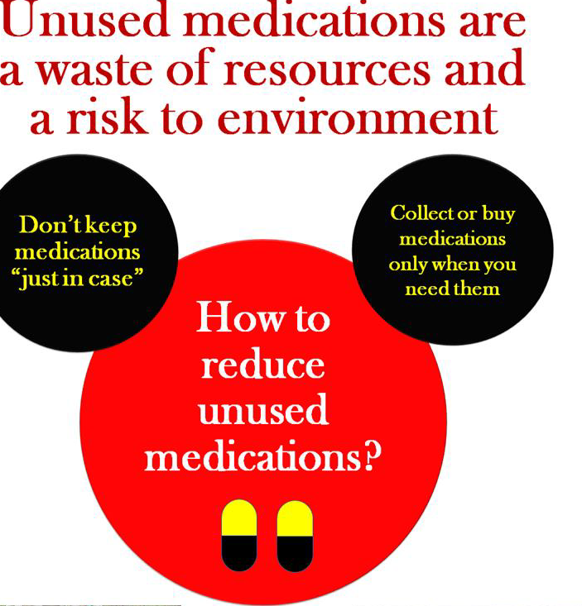



**STOCK WASTAGE & SAFE DISPOSAL**

It has been estimated £300 MILLION of NHS prescribed medicines are wasted each year.

Unused or unwanted medications contribute to economic wastage. Improper disposal of these unused medicinal products also has adverse consequences on the environment and public health. There are multiple reasons for households to process unused medications, which include medications that have passed their expiry date, the patient’s condition has improved so have stopped taking the medication, a change in medication, hoarding medications or the patient has died.

There are several routes for these unused medications to gain entry into the environment, such as through disposal as household waste that is taken to landfills, flushing medications down toilets or drains that will end up in the sewage systems resulting in possible contamination of surface water.

It is highly desirable to reduce the risk of releasing these unwanted medicinal products into the environment, which may pose harm not only to the environment but also to public health.

**HOW CAN YOU HELP?**

There are a number of ways that you can help to reduce

the issue of wasted medicines and save money for your

local Medical Centre.

* 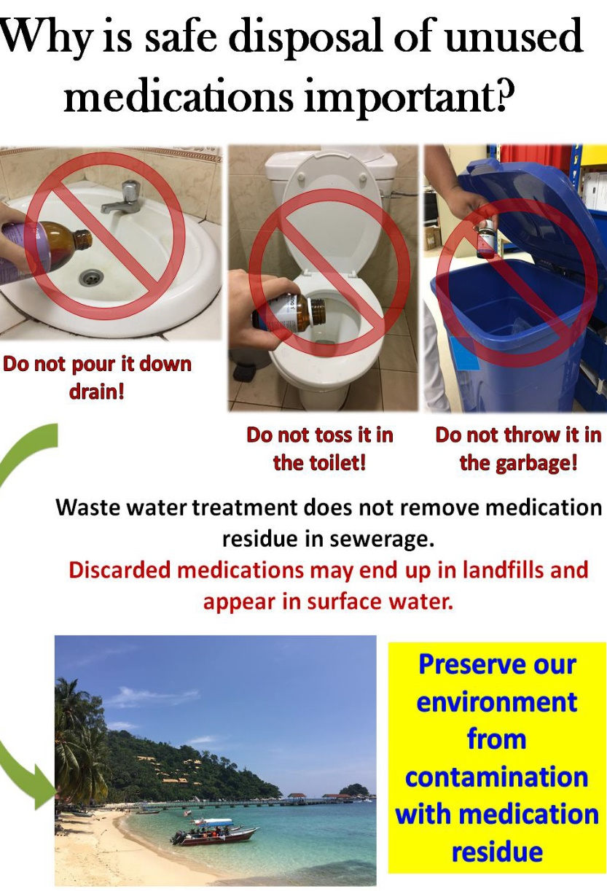Please let your GP, Pharmacist or Pharmacy

Technicians know if you have stopped taking any

of your medicines.

* Check what medicines you still have at home

before re-ordering. Think carefully before ticking all

the boxes on your repeat prescription forms and

only tick those you really need.

.

* Set a time every month or two to check your stock

of existing medications for expiry dates, condition

and amount you have left.

* Do not keep unused medications in the home as

there can be a risk of accidental poisoning of

vulnerable parties such as children, persons with

dementia, visual impairments, and pets.

* Do not share your unused medications with other

persons.

* Bring medications which have expired, spoilt, or

are no longer required to the UK Pharmacy

for safe disposal.

* Collect only the amount of medication that you

require from the pharmacy. Take into account

what you have left at home.

* Always bring a list of medications, dosages and

amount left with you to your appointment. Discuss

with your doctor if all the medications are still

required based on your recent medical condition

and test results.

You can bring any medications that you no longer use to the UK pharmacy

or Reception Office for safe disposal

Please remove personnel information labels from the outside packaging before

giving to a member of our staff

For further information on safe disposal of medicines, please contact the Mil Pharm Tech

UK Medical Practice. UKStratCom-DMS-DPHC-MON-PharmT@mod.gov.uk